Cornell Note Taking System
(For Lecture or Reading)

Taking good notes is one of several keys to academic success. There are several reasons why developing an effective technique of note taking is important.

Reasons for Developing Effective Note Taking Techniques

1. Prevents forgetting:
Our memory fades quickly. For most students, forgetting occurs very rapidly after listening to a lecture, or reading over informational material even if the material is engaging and interesting. After lectures, for example, research shows that we forget 50% of what we hear within an hour and more than 70% within two days.
2. Encourages concentration:
Taking effective notes requires a student to be mentally active during a lecture or while reading. One has to pay attention, interact with information, make decisions about what to record, and write. Given that the mind is occupied with a demanding task, there is less opportunity for the mind to wander.
3. Records testable material:
Instructors generally expect students to remember and apply facts and ideas presented in lecture or in texts. Tests are based on key ideas teachers emphasize in their lectures and/or written material that supports key concepts or themes. In other words, the testable material.

Cornell Note Taking: The Process

Introduction

There are a variety of note taking styles. No single method suits all students. However, many successful students and business people have found that the Cornell note taking system is very effective for lectures or reading that is organized around clearly defined topics, subtopics, and supporting details.

The Cornell System is both a note taking and a study system. There are six steps
to it.

Step One: Record

- Prepare your notepaper by creating a two-column table. The left- hand column should take up about 1/3 of your writing space, leaving the remaining 2/3 for recording information. Use only one side of each sheet of notepaper.
- Summarize and paraphrase (restate in your own words) the facts and ideas presented. Record definitions as stated or written.
- Indicate changes in topic with headings or by leaving a space between topics
- Number, indent, or bullet key ideas presented with each topic.
- Aim for telegraphic (brief) sentences, abbreviations, and symbols.
This will increase your note taking speed.
- Write legibly so your notes make sense to you later.
- Edit as soon as possible.

Step two: Question

Formulate test questions based on the information recorded in notes and write them in the recall clues column on the left-hand side of notes. Questions should focus on specific definitions and “big ideas”.

Cornell Note Taking: The Process

Step three: Recite

- Recitation means explaining the information in the notes out loud, in your own words. The information should be triggered by the test questions in the recall clues column.

Purposes of recitation:
  - Improves learning: Psychologists who study how the memory works say that reciting aloud is a powerful technique for anchoring information in the long-term memory.
  - Ensures understanding: Reciting requires you to think about and understand the information you are committing to memory.
  - Facilitates retrieval: Understanding information improves your ability to retrieve it from your memory. Studies show that students who recite tend to do better on tests than students who just read their notes silently to themselves.

Step in recitation:
  - Cover up the notes in the “record” column or fold notes back along line separating the “clues” from the “record” column.
  - Use recall clues to stimulate your memory and recite the relevant information.
c. Check your answers. This gives you immediate feedback on how well you have learned and are able to retrieve the information. If you have difficulty recalling the information or if your answers are incorrect, learn and recite over again.

Step Four: Reflect

- Reflection has to do with thinking about the information you are learning.
- One way to reflect is to look for connections with your own experiences and observations and with other facts and ideas discussed in class.
- Another way to reflect is to ask questions like: How do the main ideas fit together into a “bigger picture”? How do these ideas fit in with what I have already learned? What do I agree with? What do I disagree with? Which ideas are clear? Which are confusing? What new questions do I have?

Cornell Note Taking: The Process

Step Five: Recapitulate (summarize)

- Write a summary of the main ideas using your own words. This is the best test of how well you understand the information.
- Use a section at the bottom of each sheet of notes to write your summary or write a summary of all the notes on the last page of your note sheets.

Step Six: Review

- A good guideline is to review nightly or several times during the week by reciting, not rereading.
- Frequent, brief review sessions aid more complete comprehension of the material than cramming the night before a quiz/test.

Cornell Note Taking: Format

Recall Clues | Record
Write recall questions here. | Record notes here  - Remember to focus on testable information  - “big ideas”  - definitions  - supporting details  - Bullet each piece of new information and skip lines to visually organize notes
Summary:

Write a summary of notes recorded on each page in this section of your notes…
Or, create this section on the last page of your notes only, and summarize all information there.

Examples of the Cornell Notetaking System

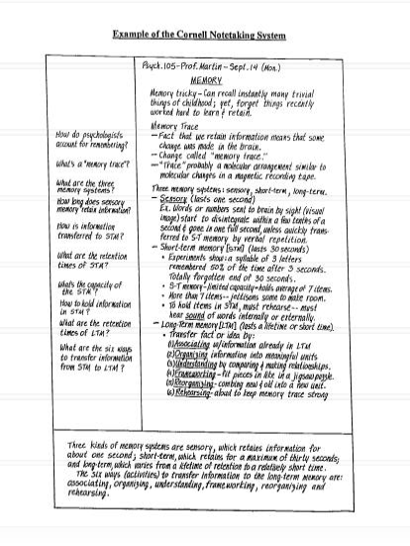

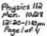• Wh6 ,,.fl, """"" f&,;.., fl./.Jt-t. ic.--.'6..
°'
{,.- -4 l JoUI- R: 1J 04j.ds
"":Sut.c dj id mot
1-

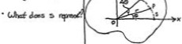·l.J•l..,4....,,. .....,.:
oil\ .p-... '

--....,
Al IJ.MO.I .-.,,.!J
f.1c.J ....;, o 1 r....,JJ..,
9•O,.A..Y ;.""......i,
9>0, cc.w
Q ..y,. ; $i$ .,,
CSl•.-.J.1-•
.49· '""" d ..'f

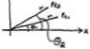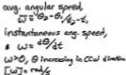• wl..J....;..il.e..<..e.•., -

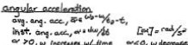
• !'ow 0. .(1••
IN-..,, •o il

